IERG 2080 asg2

**Problem 1**

**(a)**

Scp the files:



Home directory:



Compile:

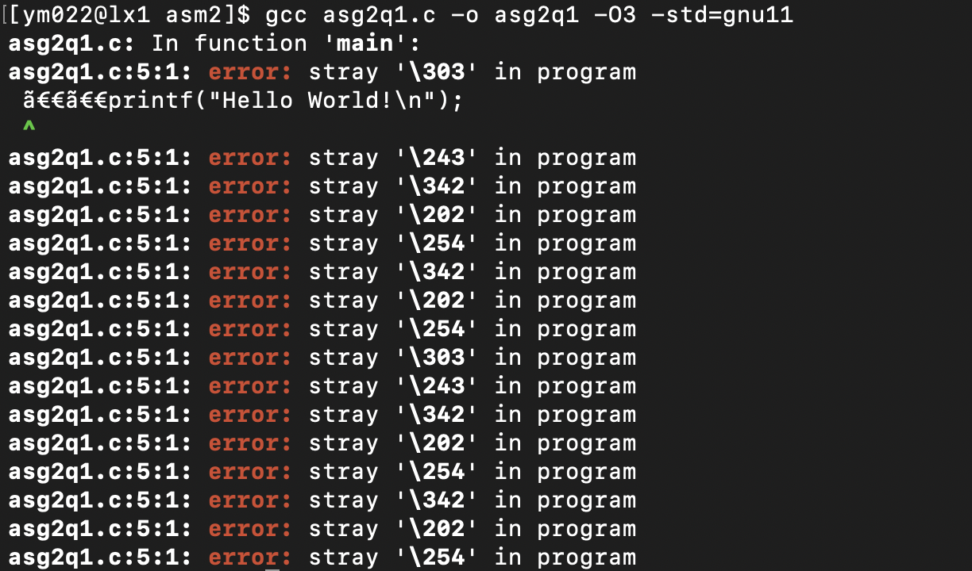

**(b)**

From the prompt “:5:1” we know that the problem is at line 5.

**(c)**

(303)8 = (c3)16

(234)8 = (a3)16

…

(342)8 = (e2)16

(202)8 = (82)16

(254)8 = (ac)16

So the problematic part is as highlighted:

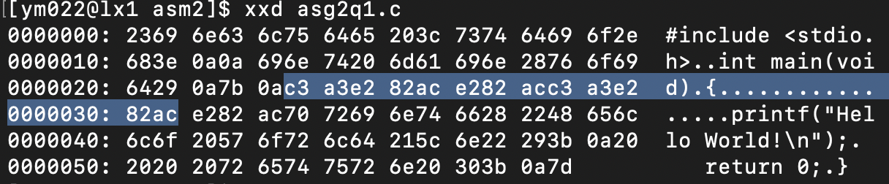

**(d)**

(20)16 = (32)10

The 32nd char in ASCII table is space (‘ ‘), so it is a space.

**(e)**

by changing the highlighted part in (c) to space gives the following xxd:

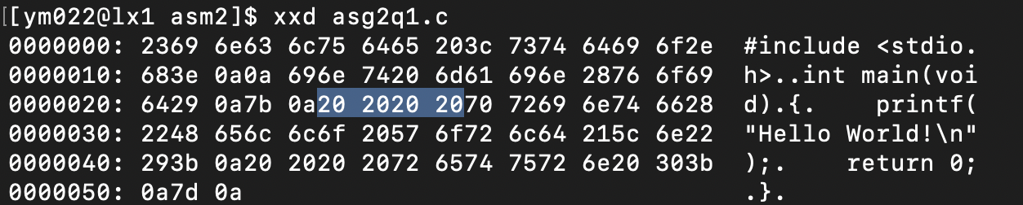

**(f)**

No we can’t.

The scp command is used to initiate the file transfer, so it needs to be executed on the computer where the file is located.

**Problem 2**

**(a)**

SIGFPE

**(b)**

7

**(c)**

x = 2, y = 0

**problem 3**

**(a)**

Log in to newuser:



**(b)**

**(c)**

**(d)**

i) read: root, original user

ii) write: root, new user

iii) execute: none